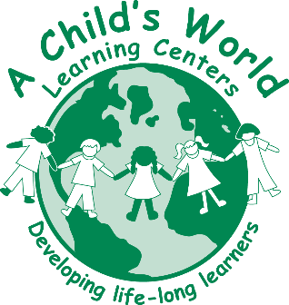
Teacher

For more than two decades A Child’s World Learning Centers, winner of the 2015 Triad Moms on Main Choice Award for Favorite Child Care Facility in the Winston-Salem area, have provided exceptional care, love and education to more than 6,000 area children. Our schools in North Carolina are located in Downtown Winston-Salem, South Winston-Salem, Bermuda Run, and Clemmons. For more information about us, visit our website at www.achildsworldnc.com.
Join our talented team as a Teacher who will impact the lives of children every day, developing them into life-long learners. This position reports to the Director and performs a variety of activities that ensures age- appropriate learning and maintains the health and safety of the group.

Responsibilities:
- Enthusiastically greet and engage with parents at drop-off and pick-up times.
- Maintain a positive relationship with parents.
- Inputs each child’s daily activities into an interactive app for parents in a consistent, timely and accurate manner throughout the day.
- Talks to parents every day about child’s activities.
- Create a soft, calm, safe and loving environment.
- Create lesson plans and executes daily scheduled activities for children, with a focus on Language Development, Social Skills, and Gross Motor/Coordination Skills.
- Ensure classroom newsletter and bulletin boards inside and outside of respective classroom are up-to-date and accurate.
- Ensure the daily care of every child by following all licensing guidelines and implementing all ACWLC company standards.
- Conduct guided classroom tours to potential new parents.
- Clean and organize classroom every day.
- Works cooperatively with and directs TA and support staff.

Qualifications:
- Associate’s Degree in Early Childhood Education or related field preferred. Bachelor’s Degree preferred.
- North Carolina Early Childhood Credentials (NCECC) required
- A minimum of two to three years of experience in a licensed child care facility
- Current qualifying letter from the North Carolina DCDEE preferred
- Knowledge of growth process of children infants to school age
- Knowledge of activities that stimulate children
- Knowledge of safety issues surrounding children
- Skills in patience
- Skills in relaying positive reinforcement
- Skills in positive communication
- Skills in time management
- Ability to organize environment
- Ability to plan and prioritize work
- Ability to move & react quickly
- Ability to communicate effectively (audibly, verbally, visually)
- Ability to assess surroundings/situations & to make decisions regarding children’s needs
- Ability to stand, walk, reach, and lift up to 25 pounds frequently. Ability to climb or balance and lift up to 50 pounds occasionally.

Benefits:
- Health Insurance
- Dental Benefits
- Paid Vacation
- Paid Holidays
- Child Care Tuition Discounts
Upon Employment Offer:
- Must complete and pass a criminal background check.
- Must meet state-required basic health requirements.
- Complete all necessary ACWLC employment and payroll forms.

A Child’s World Learning Center is an Equal Employment Opportunity (EEO) Employer.

No phone inquiries please.

Email resume to info@achildsworldnc.com

